

High-Level Scoping Document
BITS Elevate – AI-Enabled Workplace Learning System
Author:

Version

Date:

​​Table of Contents

Executive Summary 2
Problem Statement 3
Scope 3
Key Deliverables 4
Assumptions 4
EBook Learning System 7
Proposed Functional Requirements 7
Success Metrics 11
Roles & Responsibilities 11
Pilot Plan 11
Customer Support Plan 12
Closure Criteria 12
Confidentiality & IP 12
Appendix A: Glossary of Terms 12

Executive Summary
This High-Level Scoping Document defines the scope and requirements for the Minimum Viable Product (MVP) of the BITS Elevate AI-Enabled Workplace Learning Solution.
The MVP enables BITS WILP learners to apply academic concepts to real industrial problems, addressing the gap between theory and workplace practice.
It delivers a functional end-to-end system with the minimal screens and workflows required to support two pilot courses.
MVP serves as a baseline for WILP review and stakeholder engagement.

Problem Statement
BITS WILP and campus students excel in theoretical learning but struggle to apply these concepts to real industrial environments. This gap in applied competency reduces their effectiveness on the job and weakens the talent pipeline for industry partners.
Key Challenges in Applied Intelligence
1. Weak Concept-to-Workplace Mapping
Students struggle to apply classroom concepts to workplace tasks. This limits their ability to solve the problems they are hired to address.
2. Limited Structured Experiential Practice
Students have restricted access to labs, simulations, and safe practice environments especially in high-risk or high-cost industrial settings. Limited hands-on practice reduces skill transfer
3. Lack of Adaptive, Continuous Guidance
Students do not receive AI-driven feedback to guide their next steps or correct misconceptions, limiting personalized learning and efficiency.
4. Mentor Scalability Constraints
Workplace mentors cannot provide continuous, individualized coaching at a scale. As a result, students lack the ongoing support required for deep skill development.

3. Design Principles (Mandatory Governance Layer)
Every feature, workflow, and screen in the MVP must satisfy:

A. Authentic
- Content must originate from:
  - Faculty-uploaded material
  - Approved SharePoint repositories
  - Verified institutional resources
- No uncontrolled open-web knowledge base

B. Safe
- Restricted browsing
- Controlled AI responses
- Role-based access
- Moderated content ingestion
- No exposure of sensitive data

C. Enabling
- AI-driven:
  - Concept support
  - Guided reflection
  - Lab feedback
  - Workplace mentoring
  - Skill-gap insights

Scope
In-Scope
- 2 pilot courses (ADAS, Electric & Hybrid Vehicles).
- End-to-end learner journey covering Conceptual Intelligence, Experiential Intelligence, and Applied Intelligence
- Minimal screens and workflows to demonstrate concepts and engage stakeholders
Out-of-Scope
- Full LMS replacement.
- Campus infrastructure or digital modeling.
- Production-hardening for large-scale deployment.
- Comprehensive career products for all roles and industries.
- Non-WILP learners.

Key Deliverables
The Elevate System delivers three layers of intelligence that together create an end-to-end learning system:
1. Conceptual Intelligence (Learn)
Focus: AI-powered access to BITS course content with targeted retrieval, explanations, and personalized recommendations to strengthen conceptual understanding.
Key Components: Intelligent Video Retrieval, OA Tutor, Assessment Integration, JELAI for guided, in-context learning support.
2. Experiential Intelligence (Build)
Focus: Virtual and industrial simulations, including AR/VR, for safe, repeatable hands-on practice with equipment and processes.
Key Components: Controlled Experimentation (Sandbox), Virtual Labs, Immersive Labs.
3. Applied Intelligence (Apply)
Focus: Integrated learning and dissertation support, including skill-gap identification and personalized course recommendations aligned with workplace needs.
Key Components: AI Assistant, Integrated Learning Module, Dissertation Module, Career Navigation.

Assumptions
BITS Commitments
- Content and Faculty Access
BITS will provide pilot course outlines, access to faculty SMEs, and sample digital content (videos, PDFs, rubrics) in a timely manner.
- Data Compliance and Access
Any workplace data shared for demos or pilots will be covered under NDA and must be anonymized or aggregated to protect proprietary and personal information.
- Infrastructure and Hosting Support
Spanda will receive access to required development and staging environments to securely host, test, and demo the MVP.
- Technology Alignment
Technology stack decisions including cloud, databases, and core languages will align with BITS’ IT and security policies and approved vendor standards.
Technical and Delivery Assumptions
- Production Scalability
The production architecture will support thousands of concurrent learners without performance degradation.
- Data Segregation
BITS data will be strictly segregated from third-party or developer data through enforced logical and technical controls.
- AI Model Usage
All AI capabilities will use a designated API (TBD) to ensure consistency and simplify future model upgrades.
- AI Teaching Assistant (Bot)
Incorporate a multimodal AI bot that delivers personalized learning recommendations, continuous feedback, at-risk student detection, and tailored remedial learning paths.
- Deliverable
The MVP delivered for sign-off will be a functional, web-based, clickable system demonstrating user flows and core features.
- Security and Compliance Requirements
BITS expects security controls aligned with its IT and data governance policies. Spanda will work with the BITS IT team to define the specific security controls for the MVP. Key areas to be addressed include:
- Role-based authentication and authorization
- Encryption for data in transit and at rest
- Strong data protection controls
- Compliance with GDPR and applicable educational privacy laws
- Comprehensive auditing of key activities
- A defined incident response process
- Non-Functional Requirements (NFRs)
Detailed NFRs—including performance load, uptime, and browser support—will be defined and approved in the BRD.
- Success Metrics
Current metrics suffice for MVP evaluation. Production-level success metrics will be finalized in the BRD.
Design & Content Assumptions
- User Experience (UX)
Final UX specifications (wireframes, mockups, interaction flows) will be completed as part of the BRD. The MVP will use a functional UX to demonstrate capability.
- Detailed User Flows
End-to-end user flows for all roles (Faculty, Student, Mentor, Admin) will be developed and approved in the BRD.
- Initial Course Scope
MVP ingestion, core functionality will focus on two pilot courses to ensure diverse content representation:
- ADAS (Advanced Driver Assistance Systems) – SME: Prof Sajeeth Kumar
- Electric & Hybrid Vehicles (E&HV) – SME: Prof. Madhuri
Each course will have a designated SPOC faculty member.

Scalability & Rollout Strategy
To address the requirement for deploying hundreds of courses, the MVP is designed to validate the course deployment workflow. While the MVP executes this for only two pilot courses, the system design establishes the process for mass deployment.

EBook Learning System
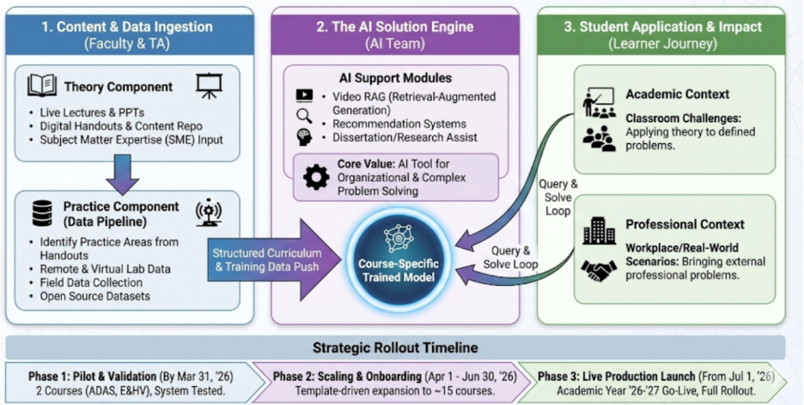

Proposed Functional Requirements
This section defines the functional requirements required to demonstrate the prototype’s core capabilities. Requirements are grouped across the seven modules for the student: Learn, Reflect, Practice, Explore, Solve, Test, Seek. Additional functional requirements will be discussed.

Module 1: LEARN
Structure
- Built only on faculty-uploaded material
- Ingested from:
  - SharePoint
  - Course uploads
  - Approved repositories
Capabilities
- Lecture summarization
- Accurate timestamp extraction
- Click-to-video navigation
- Topic completion tracking
- AI conceptual tutor (no direct giving of answers)

Module 2: REFLECT
Reflection is no longer standalone journaling.
It must:
- Link directly to completed topics
- Provide guided prompts
- Enable back-and-forth navigation to Learn
- Track reflection depth and completion
- Include structured journaling
- Feed learning profile model
Reflection to be a data layer for intelligence, not a passive diary.

Module 3: PRACTICE (Lab-Centric)
Practice is primarily:
- Lab-based
- Controlled experimentation
Includes:
- Virtual labs
- Remote labs
- Physical lab integration
- AR/VR modules
- Digital twin environments
Technical Requirements:
- iframe-based lab embedding
- Structured data generation
- AI debugging hints (never full answers)
- Validation against governing models
- Faculty-controlled model versioning

Module 4: EXPLORE
Safe exploration beyond core material:
- Restricted web scope
- Faculty-curated extensions
- Publisher API / eLibrary integration (subject to feasibility)

Module 5: SOLVE
Situated workplace learning:
- Workplace problem definition workflow
- Mentor-guided AI assistant
- Sandbox experimentation
- Hypothesis validation

Module 6: TEST
- Through assessments (EC2/EC3)

Module 7: SEEK
AI personas support layer:
- TA, faculty, and mentors

Additional points to note:
- Implement a course dashboard showing registered courses for each student.
- Define and enforce role-based access (Student / Faculty / TA).
- Restrict content upload and Knowledge Base access to faculty only.

Success Metrics
TBD in Business Requirements Document

Roles & Responsibilities
BITS WILP
- Define pilot courses and assign leads.
- Provide course materials, handouts, rubrics, and EC2/EC3 data.
- Align success criteria and provide signoff.
- Provide required infrastructure for testing and deployment.

Spanda AI
- Own BRD, UX, and technical implementation of the MVP.
- Coordinate demos and capture stakeholder feedback.
- Maintain the high-level scoping document and related design/architecture artifacts.

Pilot Plan
MVP will be demonstrated using the following courses:
- ADAS (Advanced Driver Assistance Systems) – SME: Prof. Sajeeth Kumar
- Electric & Hybrid Vehicles (E&HV) – SME: Prof. Madhuri

Customer Support Plan
- Internal Support Only – Spanda team provides demo usage and troubleshooting.
- Future pilots with live learners will require a separate support plan (L1/L2 roles, SLAs, channels).

Closure Criteria
Signoff by Professor PB Venkataraman / WILP leadership confirming:
- MVP reflects problem understanding and solution direction.
- Scope and non-scope items were respected.
- BRD serves as a baseline for next-phase requirements.

Confidentiality & IP
All work products developed under this engagement are governed by a mutual confidentiality agreement. IP ownership, licensing, and reuse terms to be defined in the master services agreement or addendum.

Appendix A: Glossary of Terms
Term | Definition
MVP (Minimum Viable Product) | The minimal functional version of the solution that delivers core screens and workflows to support pilot courses.
Conceptual Intelligence | AI-powered learning layer that helps learners access course content, retrieve relevant material, and strengthen understanding of theoretical concepts.
Experiential Intelligence | AI-powered learning layer for virtual and industrial simulations, AR/VR labs, and hands-on practice with equipment and processes.
Applied Intelligence | AI-powered layer for integrating learning into workplace problems, including dissertation support, skill-gap analysis, and personalized course recommendations.
Workplace Mentor | A subject matter expert or faculty member providing guidance, coaching, and feedback to learners on practical application of concepts.
Pilot Course | A selected course used to validate the MVP, including sample content, workflows, and user interactions.
EC2 / EC3 | BITS assessment frameworks are used to track learner progress and identify conceptual gaps.

Version History
Version | Date | Author | Description / Changes Made
0.01 | 12/01/2025 | Shreya Ramesh | Initial version based on the presentation with Prof Venkat and Prof Sundar
0.02 | 12/10/2025 | Shreya Ramesh | Added suggested modules
0.03 | 10/02/2026 | Deepika | Added platform modules based on the discussion on 3rd Feb, 2026

